STUDENT ORIENTATION

REFERENCING AND PLAGIARISM EXERCISES

University of Tasmania

September 2021

CRICOS Code 00586B
REFERENCING

Exercise 1: Is a reference needed?

Tick whether a reference is needed or not in the following situations:

Situation | Yes | No
When quoting something directly from a website
When using statistics or other data that is freely available from a reference book
When summarising the cause of past events, where there is agreement by most commentators on cause and effect
When paraphrasing a definition found on a website, where no writer, editor or author’s name is found
When summarising the ideas of a particular author, which have been paraphrased by another person – e.g. when author A paraphrases what author B has said
When summarising in your concluding paragraph what you discussed and referenced earlier in your text
When including photographs or graphics that are freely available on the Internet, where no named photographer or initiator is shown
When paraphrasing an idea you have read that you feel makes an important contribution to the points made in your assignment

Exercise 2: “I didn’t cite the source because….”

Below are six statements that might be made by a student for not citing and referencing a particular source in an assignment. Imagine that you are a tutor and match the likely response to the statement.

Statements  “I didn’t cite the source because…” | Response Number:
…I listed all the sources in the reference list instead
…I found this theory on Wikipedia; anyone can contribute to that and no author is named
…The statistics were taken from a Government website – it is there for the whole world to see
…It just gave me ideas to use in my assignment; I changed most of the words in the article to my own
…It was from the lecture slides; everyone in the class has a copy
…No author or writer’s name was shown on the website

Tutor responses
Match each of the previous statements with the appropriate tutor response from the list below:

- If no named author or writer is shown, you should cite and reference the name of the originator of the source. This can be the name of an organisation.
- Readers need to match in-text citations with the full details of sources in a list of references. This enables readers to find and use the sources for themselves.
- The source of all data must be fully cited and referenced, even if they are openly accessible.
- It is advisable to use academic sources (e.g. textbooks and journal articles) wherever possible. Primary sources, in this example, the original theory should be used as secondary sources may not be reliable. If you do use a secondary source it must be properly cited and referenced.
- Any source that has made a significant contribution to your assignment must be fully cited and referenced. By doing this you acknowledge the part that the other person has played in the development of your own ideas (rather than claiming the ideas are all original and your own).
- This came from work produced by someone else, not by you, and so must be acknowledged. It also contributes to the reader’s understanding of terms you have used in your assignment and so needs to be properly referenced.

Exercise 3

Write a reference list for the five different sources attached
- Book with one author
- Book with more than one author
- On line journal article from UTas Library
- On line journal article from EBSCOhost
- Webpage from website

Reference List

________________________________________________________________________________________________________________________________________________________________________________________________________________________________________________________________________________________________________________________________________________________________________________________________________________________________________________________________________________________________________________________________________________________________________________________________________________________________________________________________________________________________________________________________________________________________________________________________________________________________________________________________________________________________________________________________________________________________________________________________________________________________________________________________________________________________________________________________________________________________________________________________________________________________________________________________________________________________________________________________________________________________________________________________________________________________________________________________________________________________________________________________________________________________________________________________________________________________________________________________________________________________________________________________________________________________________________________________________________________________________________________________________________________________________________________________________________________________________________________________

PLAGIARISM

Plagiarism is the practice of knowingly using another person’s work and claiming it, directly or indirectly, as your own.

Exercise: Is it Plagiarism?
Which of these scenarios do you think would be regarded as plagiarism by most universities in Australia and China? Tick either ‘Yes’ or ‘No’.

- You see a useful article in a newspaper that will be helpful in your assignment. You copy 40 per cent of the words from this source, and substitute 60 per cent of your own words. You don’t include a citation or reference, as the journalist or writer’s name is not shown. | Yes | No
- You summarise a point taken from a Unit handout that presents an overview of the work of others. You do not reference the handout, as it is just for the limited use of the students doing your course. | Yes | No
- You are part of a study group of six students. An individual essay assignment has been set by a tutor. Each member of the group researches and writes a section of the essay. The work is collated and written by one student and all the group members individually submit this collective and collated work. | Yes | No
- You include the expression ‘Children should be seen and not heard’ in your essay without a reference to a source. | Yes | No
- You overhear a conversation between two students, both known to you, discussing a subject of interest to you for an assignment you have to write. One student makes some interesting points which  you make a note of and later use the unreferenced ideas in your assignment. | Yes | No
- Your command of written English is not as good as you would like it to be. So you explain to another student what you want to say in an essay – all your own ideas - and that student writes it for you, and you then submit it. | Yes | No

Sources for Referencing Exercise 3
Book with one author

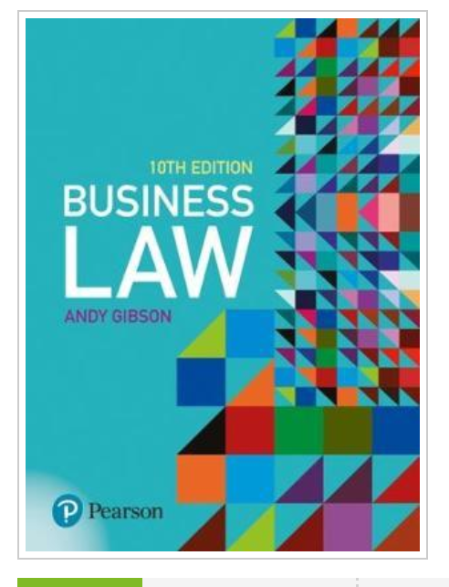

Book with two authors

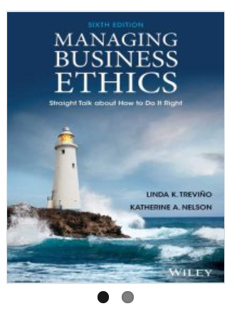

Online journal article from UTas Library

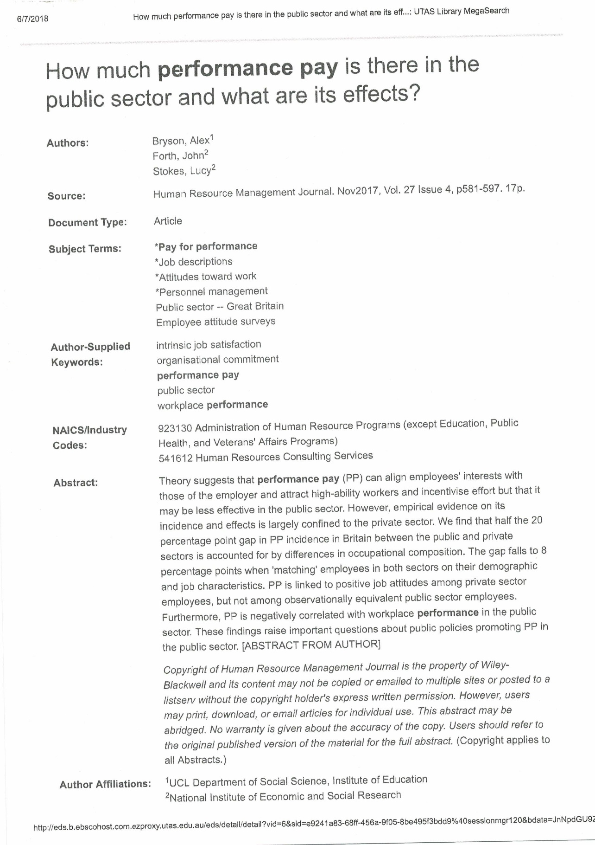

Online journal article from EBECOhost

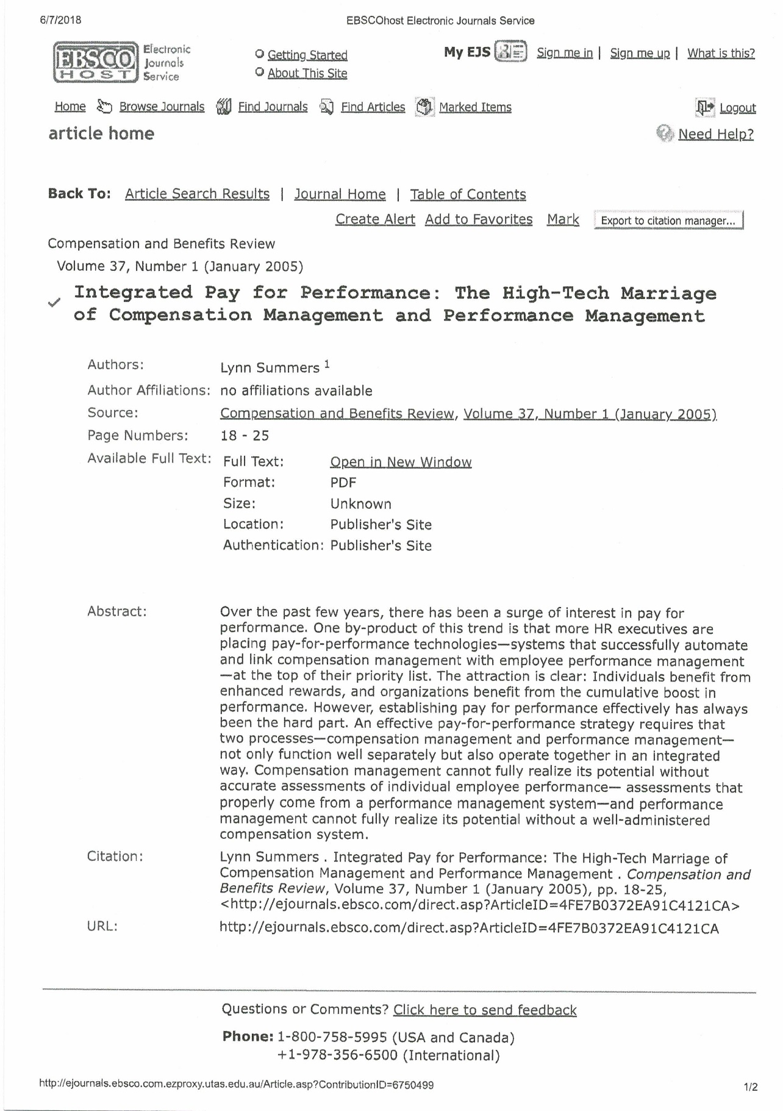

Website home page

